# Making Your World with the Aurora Toolset

The goal of this tutorial is to build a very simple module to ensure that you've picked up the necessary skills for the other tutorials. After completing this tutorial, you will have learned how to use the Aurora Toolset and be ready to start using ScriptEase II.

We will be creating a game loosely based off of part of Robert Louis Stevenson’s pirate adventure novel, Treasure Island. The player will have to fetch some rum for the Captain, complete a puzzle to find some treasure, and then gather the crew before leaving the island.

Here are some guidelines before we begin:

1. Quotation marks indicate the exact title of a menu, button, tab, etc. For example, “Door Properties” refers to the Door Properties window.
2. Aurora Toolset may be shortened to Aurora and ScriptEase II may be shortened to SEII.
3. There are menus and dropdown boxes in both AT and SE2. If you are required to navigate down a path of these, the path will be indicated with arrows. For example, Edit 🡪 Module Properties 🡪 Events in AT will take you from a menu to a specific tab in a popup.

## Getting Started:

1. Open the Aurora Toolset by opening Neverwinter Nights on your computer and then clicking on the “Toolset” button on the screen that pops up.

Tip:A **module** is basically a collection of areas. Most games made in the Aurora Toolset take place within one module. It is possible to use multiple modules for one game, but that is out of scope of this tutorial.

1. Select “Create a new Module” and click ok.
2. In the “Module Wizard” that pops up, under “Module Name,” enter “Treasure Island” as the name of your module then click next.

## Creating Areas:

1. Click on the Area Wizard. In the popup, name the area “Treasure Island” and select the “Tropical” tileset. Make the area 8x8 (medium) size. Click “Next” then “Finish” to go back to the “Module Wizard”.
2. Open the area wizard again and create a 2x2 (tiny) area called “Captain’s Quarters” with the “City Interior” tileset.
3. Open the area wizard one more time and create a 4x4 (small) area called “Cave” with the “Mines and Caverns” tileset.
4. Once the areas are made, you will be back in the “Module Wizard”. Click next and finish. You will now be in the main view of the Aurora Toolset.
5. Save your module using the name “Treasure Island” before continuing. Make sure you save every time you make a significant change so that you do not lose anything. It is also recommended to keep some backup copies of your module somewhere so that you do not lose it if the save file is lost, or an irreversible change is made.

## Navigating the Aurora Toolset:

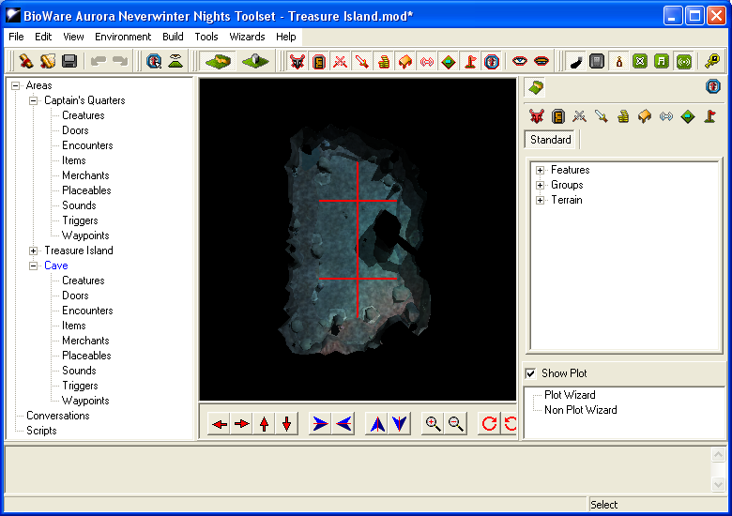

1. Now that you’re in the toolset, let’s take some time to look around. At the top of the screen, you will see a standard menu bar that is similar to many applications. We will look at this more in depth over the course of the tutorial.
2. Directly underneath this is another toolbar with various buttons. These let you control your view of the area, such as whether certain types of objects should be shown, or if the ambient music should play in the toolset. There are also some shortcuts to module file operations and undo/redo.
3. The big view in the middle is your area view. Right now, you should see a bird’s eye view of the area. You can use the buttons underneath the area view to navigate around.  
   Z:\SE2 tutorials\toolset buttons\reorient view.PNG

Tip:It’s quicker to use a combination of mouse and keyboard commands to move around. To pan the camera, hold down Ctrl and drag with the left mouse button. You can use your mouse’s scroll wheel to zoom in and out. Hold Ctr and drag the right mouse button to rotate the camera around the center. Take some time to get used to these controls.

Tip:If you find yourself in a strange position, click the “Reorient Camera” button on the above toolbar:

1. To the left of the area view is the asset view. This lists all of the assets currently in your module by area and then by type. There is also a script category. The scripts generated by SE2 will appear here with names starting with “se_”.
2. Underneath the area view is the console. If there are any errors when saving your module, they will be described here.

## Painting Terrain:

1. To the right of the area view is the palette. This is used to create new objects or paint terrain onto the area. Let’s paint some terrain onto our Island to make it look like an island instead of a grassy plain.
2. Double click on the “Treasure Island” area in the asset view to load it as the current area.

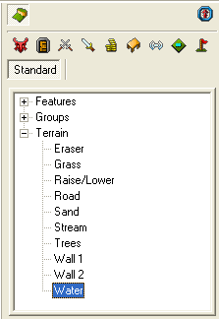

1. In the palette, select the “Water” terrain type. Let’s paint the entire area with water instead of grass. Click the left mouse button on a tile in the area view to paint it with the selected terrain. You can also hold down the mouse button to paint multiple tiles as you drag around.

Tip:The shadows from the palm trees may remain. Don’t worry; these will not appear when playing the game. To refresh the lighting, press the F5 key.

1. Now that you have an ocean, create an island using the “Sand” terrain type to match the image below. It won’t look exactly the same as the image. Just make sure the island is roughly the same size. The trees are randomly placed, so don’t worry about them.

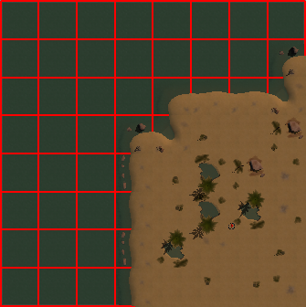

1. Invisible walls can ruin a player’s immersion when they are encountered. So let’s add a forest around the edges of our area. We can’t add “Trees” terrain on top of “Sand”, so paint some “Grass” terrain before adding “Trees” to match the image below. Again, yours do not have to look exactly the same as in the image.

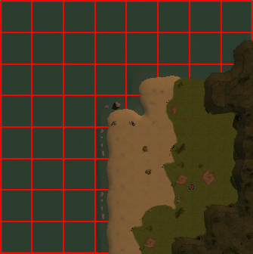

1. Notice that we still have some invisible wall area. Later in the tutorial, you will learn how to add placeables, which can also be used to block off parts of the level.

## Adding Groups:

1. Our island is supposed to have a cave, so let’s add one. Open the “Groups” category and select “Mysterious Cave”. You will notice that there is now a ghost image of a cave in the area view wherever you hover with the mouse. Once the Cave is selected, right clicking will rotate the cave and left clicking places it. Place the cave to match the below screenshot, facing away from the forest.

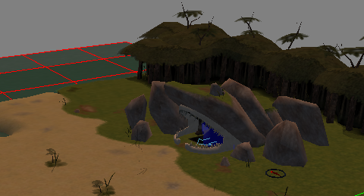

1. Since this is a pirate game, we must also have a pirate ship. In the “Groups” category, find the “Merchant Ship – Ship to Sand” group and add it to the area to match the below image. Remember to select the ship first, rotate it with right clicks, and then place it with a left click.

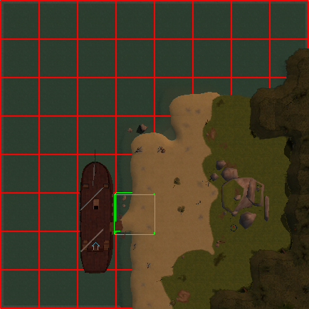

## Painting the Start Location:

1.  The player start location is still in the center of the map. This is the blue circle with a red arrow in it. When the player loads up the module, the Player Character (PC) will start in this location. However, we want them to start on the ship. Click on the “Paint Start Location” tool in the palette view and paint it on the ship.
2. Use the object rotation buttons on the bottom of the area view to rotate the location to face the plank leading off of the ship.

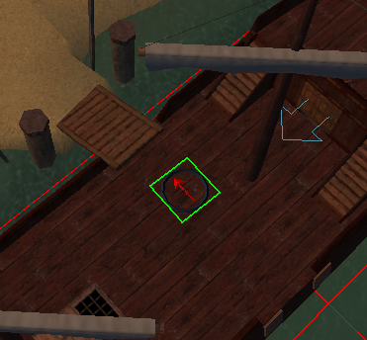

1. Now would be a good time to save if you haven’t in a while.

## The Other Areas:

1. Let’s open the Captain’s Quarters area. You will notice that it looks much too large for the ship. Aurora does not allow us to create areas smaller than 2x2, so we have to do it artificially. Select the “Wall” terrain and paint over the entire area so that it is black. Then select the “Doorway” terrain and paint it in the bottom right corner. That’s it!

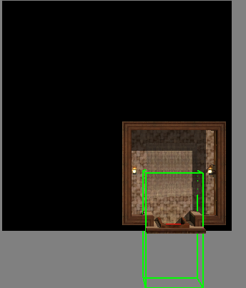

1. Using what you have learned, make the Cave area look like the image below. You will have to use the “Wall”, “Water”, “Floor”, and “Doorway” terrain types.

Tip:You can change the appearance of terrain by painting the same tile multiple times.

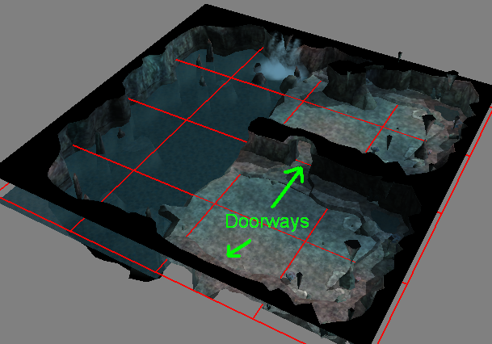

## Placing Game Objects:

1. Now that we have painted our terrain, we need to add some game object.

Tip: **Game Objects** are objects that the player can interact with, although they do not have to. Some examples are doors, treasure chests, and tables. Triggers and waypoints are special game objects that we will cover later.

1. For now, let’s create some doors so that we can connect our different areas. Navigate back to the Captain’s Quarters area. In the palette, select the “Paint Doors” palette by clicking on the door icon. Navigate to “Universal” 🡪 “Wood”. Right click one of the “Wood Doors” and click “Edit Copy”.



1. The “Door Properties” pop-up is a lot more complicated than the last, so please don’t be too alarmed. You won’t have to use most of these options. Change the Name to “Pirate Ship Door” and change the tag to “pirate_ship_door”. Then click “Ok”.
2. Place the door in the only doorway in the area. The door may not stick in the doorway the first time you try this. The easiest way to make sure it stays is to position the area view camera in the room facing the door before trying to add the door.

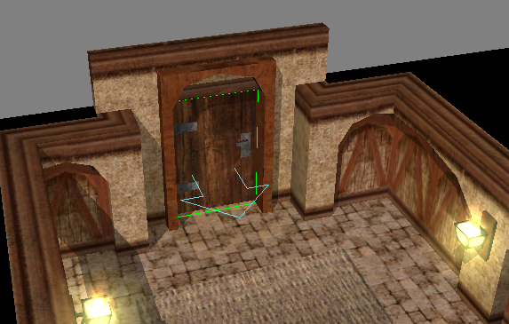

1. Notice that the palette will have switched to show “Custom” objects instead of the “Standard”. “Edit Copy” creates a custom blueprint for an object. ScriptEase II can only see objects that have a custom blueprint, so any objects that you want to control with ScriptEase II must be created with “Edit Copy”. For purely cosmetic placeables, such as paintings or chairs, you can directly add them into the area from the “Standard” palette.
2. You can add existing objects to the palette as well. To demonstrate this, let’s go to the “Treasure Island” area. Save your changes, then switch to the other area.
3. In the asset view, under “Areas” 🡪 “Treasure Island” 🡪 “Doors”, find “Ship1Door”. Right click on it and click “Add to Palette”. This will pop up the same Door Properties window as before. While we’re here, let’s change the name and tag to something more descriptive. Name the door “Captain’s Quarter’s Door” and the tag to “captains_quarters_door”. Let’s also lock the door by going to the “Lock” tab and selecting “Locked” and “Key required to unlock or lock”.
4. The door in the area will still be the original, so you need to delete it and then add the custom door in its place. Click on the door that is on the ship, press Delete, then add the new “Captain’s Quarters Door” to the ship.
5. Let’s go back to the Cave area and add two doors here. First, we need a door to the Cave entrance. However, caves don’t really have doors. Make sure the “Paint Doors” palette is selected and the “Standard” filter is on.
6. Go to the “Other” category and Edit Copy “Area Transition (No Visible Door).” Name it “Cave Opening ” with the tag “cave_opening”. Place it in the entrance. You may have to rotate the area to make the door fit. You will see the importance of this door in the next section.
7. The second door will be a bit different. We don’t always just want doors between different areas, but sometimes within areas, too. Edit Copy the door “Metal”🡪”Portcullis” and name it “Treasure Room Door” with the tag “treasure_room_door”.
8. Lock this door as well, with a key required to unlock it. Place it into the doorway in the center of the area. Make sure the blue arrow faces towards the entrance; if the door were backwards, the player would not be able to open it.

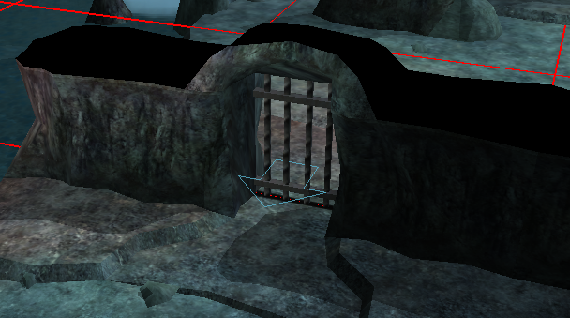

1. Why don’t we try testing the area? Test the module by pressing F9 on your keyboard. The player character will be whichever one is at the top of the alphabetically sorted character list. You will notice that you can’t actually enter the cave. This leads us to our next section.

## Area Transition:

1. To change areas, such as from Treasure Island to Captain’s Quarters, we need to tell NWN where the transitions should be and how they should work. Select the Treasure Island area. In the asset view, right click on “captains_quarters_door” and select “Properties”. The “Door Properties” dialog will open again. Click on the “Area Transition” tab then click on “Setup Area Transition”.
2. Under the “Target Area” checkbox, select the Captain’s Quarters area. Select “pirate_ship_door”, which is the only option available anyways. Make sure “Both Ways” is selected under the “Connection Type”. Click Ok. The Aurora Toolset may complain about invalid tags. Ignore the warnings and click “Yes” all the way.
3. Now edit the “RuralExit” door. Rename this to “Cave Entrance” and then set up the area transition like in the previous steps, except to “cave_opening” in the Cave area.
4. Test out the transition in NWN. You won’t be able to test out the Captain’s Quarters since the door is locked.

## Creatures and Placeables:

1. A pirate ship needs a captain, so let’s add one in. All living things are under the “Creatures” palette. In the palette, navigate to “Creatures” 🡪 “NPCs” 🡪 “Humans” 🡪 “Bandit Chief”. Create a copy of the chief. Change the First Name to “Captain Silver” and tag to “captain_silver”.

Tip:You should always check a creature’s faction before adding it to the game.

1. By default, Bandit Chiefs are hostile to the player character. Let’s change this by going to the “Advanced” tab and setting the “Faction” to “Defender”.
2. Place the captain near the ship entrance and rotate him so that it is obvious to the player that they should talk to the captain.

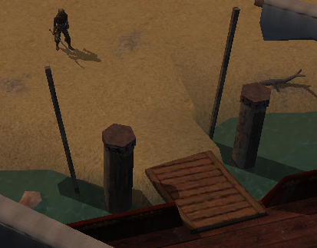

1. We also want to add a bit of context to the scene, so let’s add a pirate flag. Navigate to “Placeables”🡪 “Penants & Signs” 🡪 “Flag”. The first “Flag” looks like a pirate flag, so Edit Copy one with the name “Pirate Flag” and tag “pirate_flag”. Check the “Useable” checkbox on the same tab to allow the player to click on the flag. Click “Ok” and ignore any warnings you may get about ResRefs.
2. Place the pirate flag beside Captain Silver, making sure the blue arrow faces the same direction.

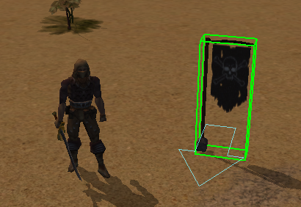

1. Let’s also block off the cave so that the player doesn’t go down there yet. Create a copy of “Placeables” 🡪 “Parks & Nature” 🡪 “Tree 0, Large” and name it “Large Tree” with tag “large_tree”.
2. Instead of placing just one, we want to place enough trees to block off the entrance to the cave. Hold shift while placing the trees to place multiple. You should be able to get away with three trees. Test out your module to see if you can get past them.

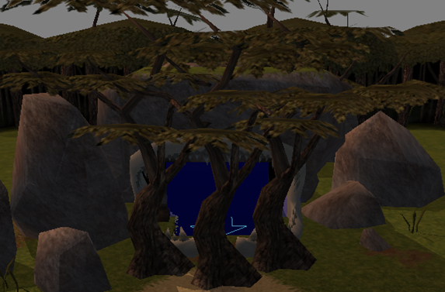

Good job! You have created your first world from scratch. We are now ready to make our world work. Save your module once more and move onto the next tutorial which will introduce you to ScriptEase II and add some life to your world.

This is a good time to make a backup copy of your module. To do so, go to the modules folder and create a copy of the Treasure Island module.

If you want, you can continue to add some more placeables to your to make it look more alive before moving on. You can also try setting the weather and lighting of your areas by navigating to “Edit”🡪 ”Area Properties” 🡪 “Visual”.